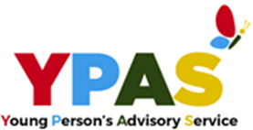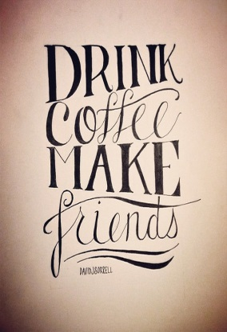

**YOU ARE INVITED TO YPAS PARENTS/CARERS VIRTUAL COFFEE EVENTS**

**GREAB YOURSELF A BREW AND JOIN US ON**

**27/5/2020**

**AT 10-1130 VIA ZOOM**

**AND DISCUSS SCHOOL TRANSITION DURING AND AFTER COVID WITH THE LIVERPOOL CAHMS MENTAL HEALTH SUPPORT TEAM**

**PLEASE BOOK TO RESERVE A PLACE USING BOOKING FORM PROVIDED**